

**INGENIERÍA**

**DE SOFTWARE II**



**PhD. Mónica Villavicencio**

**Acceptance Testing**

Authors:

**PoliSolutions**

Parallel: **2**

URL: <https://github.com/lindthon/AcceptanceTesting>

PART 1:

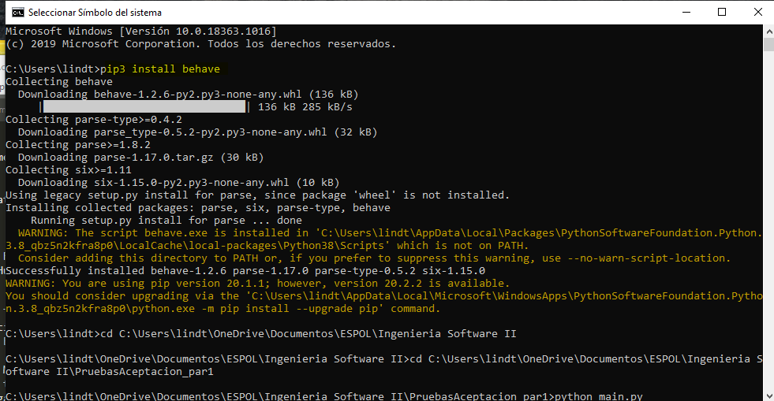

Figure 1 Install behave

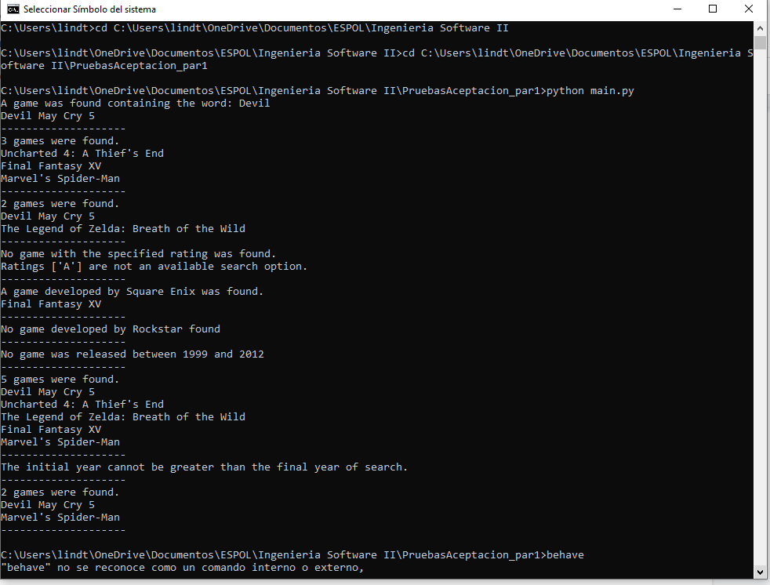

Figure 2 Run the main.py

PART 2:

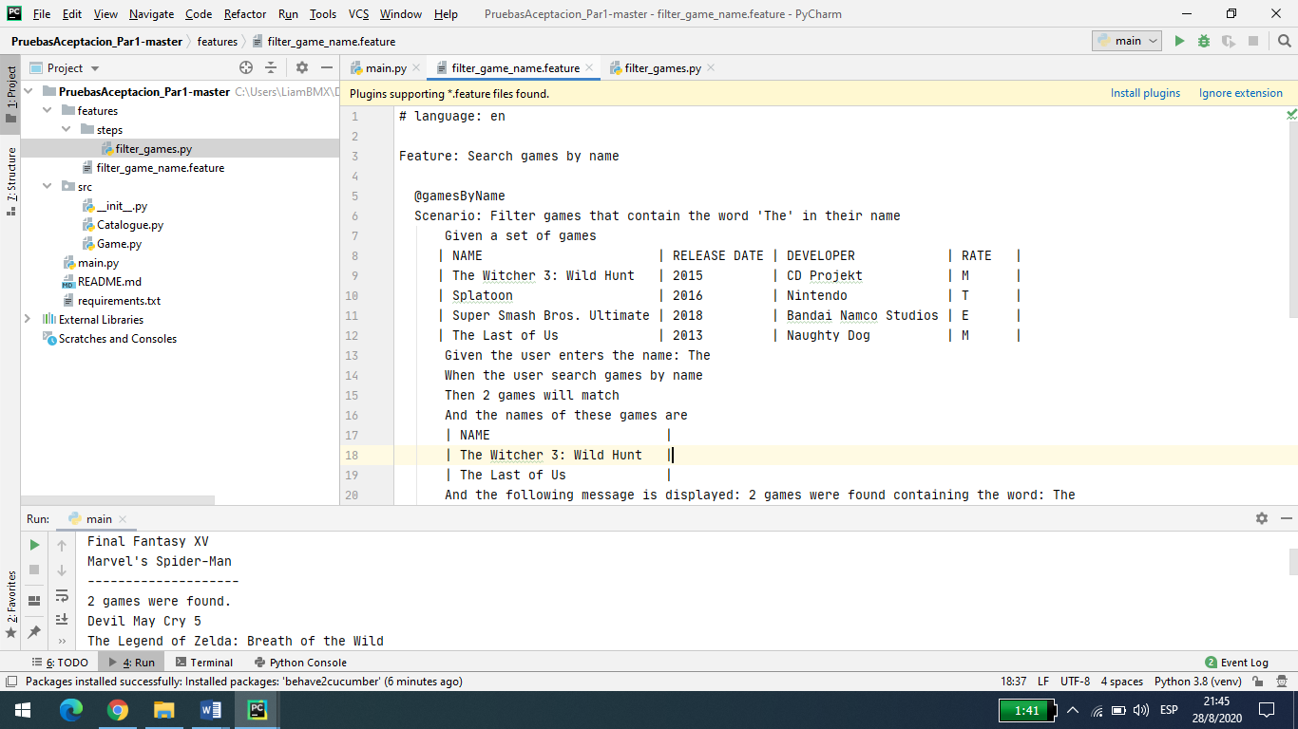

Figure 3 Review file features/filter_game_name.feature

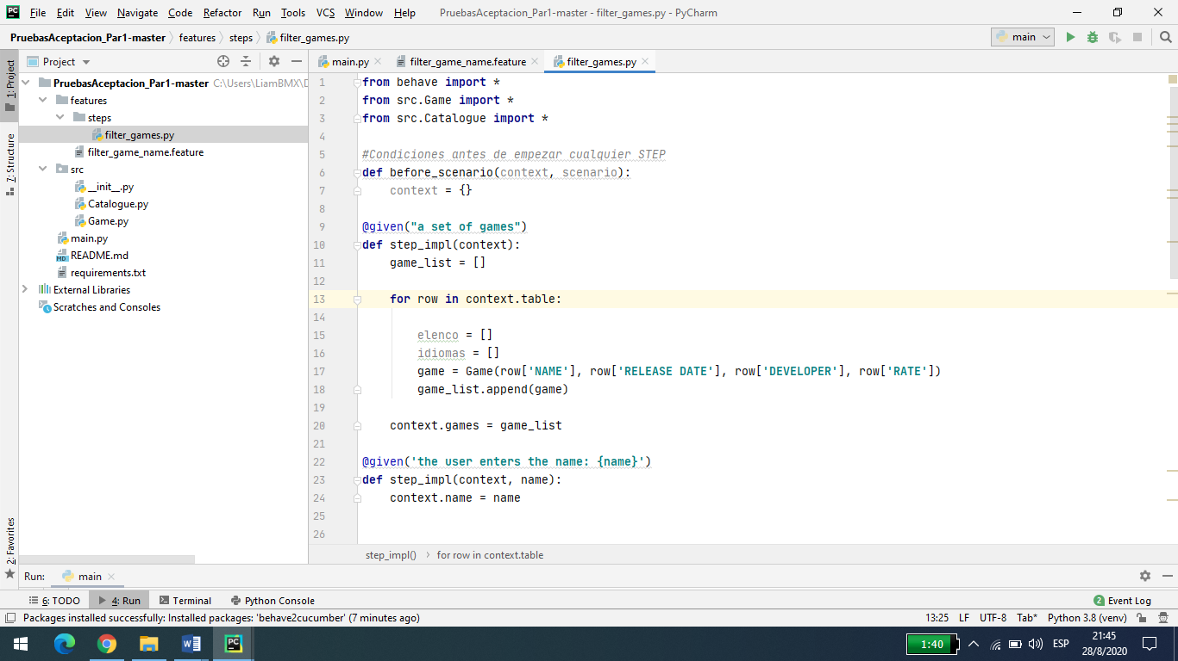

Figure 4 Review file features/steps/filter_games.py

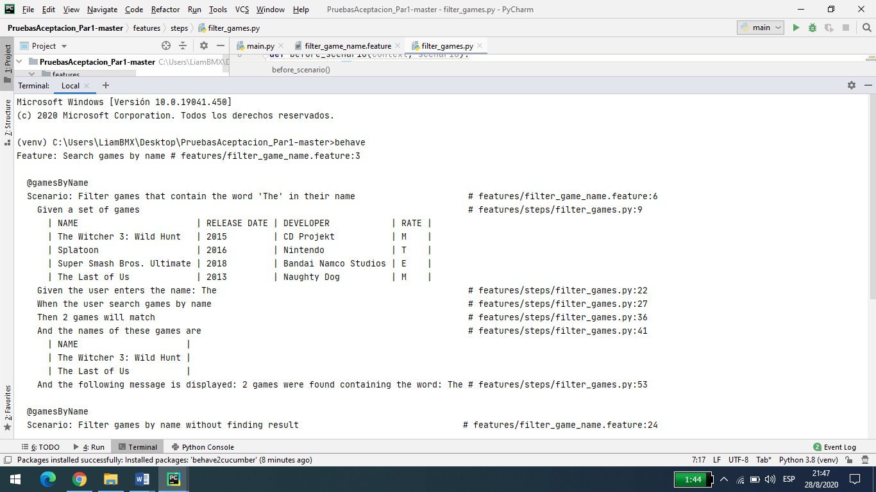

Figure 5 Run the acceptance test and analyze the result

PART 3:

1. As a user I want to view a list of the games by rating, selecting one or more categories [E, T, M] to find games by type of audience.

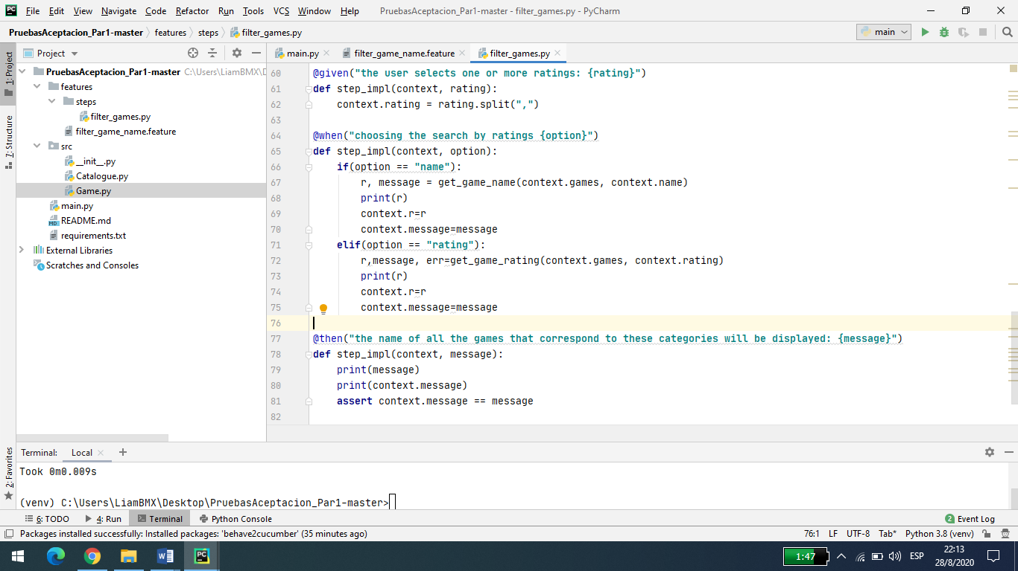

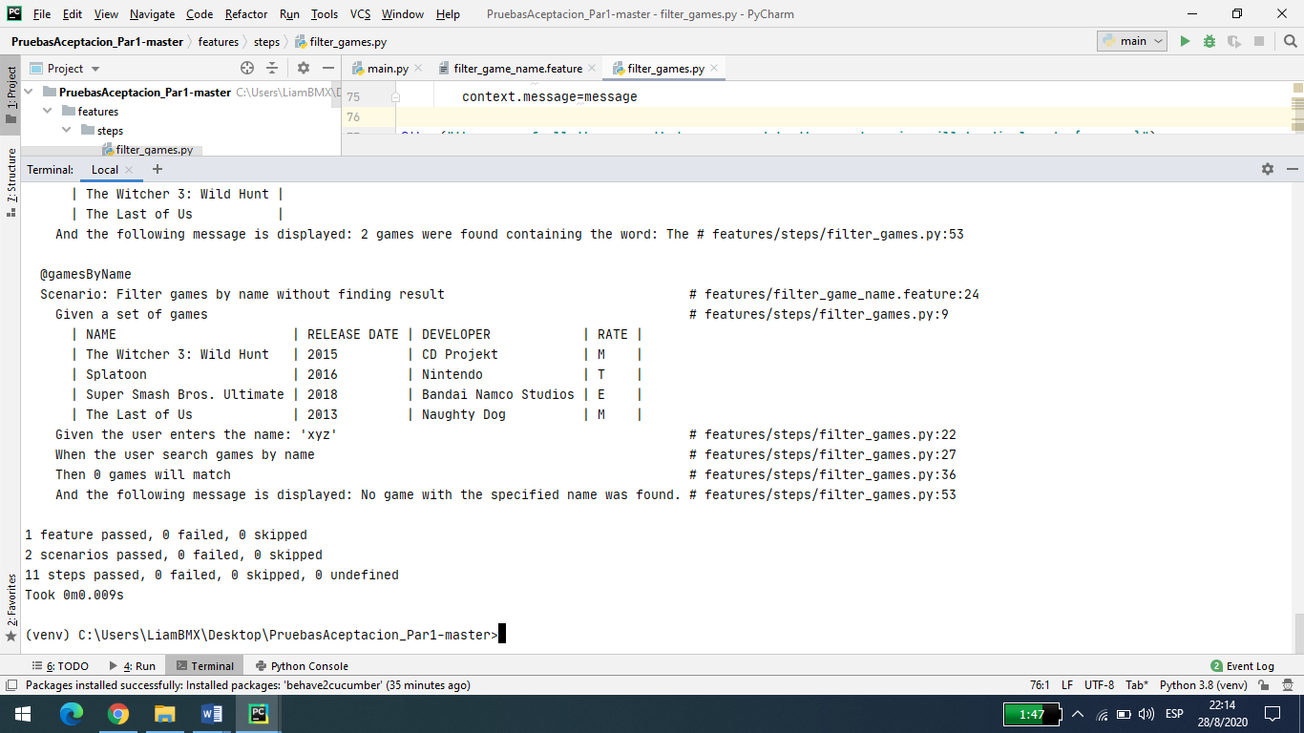

1. As a user I want to get the list of games by manufacturer to find all the games that have been developed by a certain video game studio

